
Competitor Information

Trentham Boat Club Regatta
31 May 2026 at the
Trentham Garden Estate

Contents

1 Introduction 3
1.1 Access Information 3
1.2 Coaches and Competitors Information: 4
1.3 Pre-Existing Medical Condition: 5
1.4 Junior Victor Lundorum scoring: 5
1.5 Emergency Resources 5
1.5.1 On water safety 5
1.5.2 On site medical assistance 5
1.5.3 Emergency Services access 5
1.5.4 Welfare Procedures 5
1.5.5 Fire procedures 5
1.6 Alternative Arrangement Plan 7
1.7 Rules of Racing 8
1.8 Boat Safety Requirements 9
1.9 Crew Safety 10
1.9.1 In the event of a racing incident 10
1.9.2 Coxswains 10
1.9.3 Junior and Novice crews 11
1.10 Embarkation and Landing 11
1.11 Rowing the Course 12
1.11.1 Navigating to the start: 12
1.11.2 Navigating the race: 12
1.11.3 Hazards: 12
1.12 Road and Parking Safety 13
1.12.1 Trailers 13
1.12.2 Cars Carrying Boats 13
1.12.3 Parking for vehicles without boats 13
1.12.4 Important Notice: 13
1.13 Emergency Plan 14
1.14 Incident on the Water 14
1.15 Evacuation of lake 14
1.16 Incident on Land 14
1.17 Emergency Services Procedure 15
1.17.1 Safety boats 16
2 Appendix 1 - Fire Emergency Evacuation Plan 17
3 Appendix 2 - EMERGENCY CONTACTS 18
4 Appendix 3 – Course Map 19

Introduction

Trentham Boat Club’s annual regatta is well established event run in a friendly and safe, yet competitive environment.
If further information is required, please contact the race organiser Naomi Ellis (N.J.Ellis@staffs.ac.uk).
Trentham Estate have introduced Beavers into the lake. No crews are to alight on the islands and care should be taken to minimise any potential disturbance to the nesting beavers. Please ensure that any gates are kept closed and not propped open.

Access Information
If using SatNav, enter a postcode of: ST12 9HR. This will take you to the Strongford Garage roundabout, follow the Monkey Forest signs onto Trentham Estate. Parking for trailers is directly ahead, and to reach the boathouse follow the track to the right of the car park (see appendix). Spectators will need to park as instructed by parking attendants.
OS reference: SJ 87196 38979: What Three Words location for the boathouse – darker.punchy.pepper
There will be a representative from Trentham Boat Club in the car park.
On arrival, please head to the representative to obtain regatta visitor passes for all supporters so that they can enter the lake area. Race participants and spectators with a regatta visitor passes are restricted to the area between the launching stage (west side of lake) and the spectator area (east side of lake – please refer to the map). To obtain full access to the garden, a Trentham Gardens visitor pass can be purchased from the café.
It is important that everyone obtains a regatta visitor passes otherwise Trentham Gardens will charge you a fee to enter the area by the lake. Trentham Estate monitor this and will be checking to ensure we give people visitor passes. Please help us by making sure you obtain one.

Coaches and Competitors Information:
- Registration and Race Control are located outside the boat house (by the entrance if raining).
- Coxes need to weigh in at Registration
- The boat checking and ‘pairing’ area is near the trailer park and is signposted. Please ensure that all crews report to boat pairing with their boat prior to racing.
- Crews will NOT be called to boat; it is your responsibility to ensure you boat on time. Any problems should be reported to Race Control.
- Boating is 20 minutes before the event starts, therefore crews should report to the boat checking area at least 30 minutes before the event is due to start. If your event has bands, please report 30 minutes before the first race in your band. If any crew feels they will be late to boat pairing, they must inform boat pairing and their opposition before the designated pairing time.
- There are two landing stages and have been designated and the ‘on’ and ‘off’ stages. The ‘off’ stage is directly in front of boat house. The ‘on’ stage is further round, accessed by a path from boat pairing.
- Members of Trentham Boat Club will be available to help crews boat efficiently, but please bear with us. Ensuring that all rowers and boats are prepared will help to reduce delays on the landing stage.
- Crews’ shoes will be transferred from the ‘on’ stage to the ‘off’ stage by members of Trentham Boat Club.
- As crews head up to the start line, they should keep to their stroke side and make their way up that side of the islands (the opposite side from the racing). Please see section - Rowing the Course and course map (appendix) for hazards and further info.
- A ‘pre-start’ marshal will be located by ‘the statue’ at the far end of the lake. Crews should listen for instructions about lining up at the start. Please be at the statue 10 minutes before the race is due to start.
- Lane 1 is the lane closest to the bank. Lane 2 is closest to the island. The lowest number goes to lane 1 and highest to Lane 2.
- We are operating a ‘winner stays on’ policy for any events that are not a straight final. Please ensure that rowers are aware (before they boat) that if they win their race, they are to make their way back up to the start (going behind the islands) ready for their next round. If Crews wish to return to the landing stage prior to their next race, they need to inform the marshals as they will be directing winners back to the start.
- Winning crews should report to Race Control with BR licences so they can be checked before receiving pots. Each crew member must report with their licence in person so photographs can be matched with each athlete.

Pre-Existing Medical Condition:
- It is your and your coach’s responsibility to inform the race organizers (Naomi Ellis – N.J.Ellis@staffs.ac.uk ; Safety Officer - Dermot Houlahan- dermot.houlahan@gmail.com) if a rower has a pre-existing medical condition that may impact their safety or that of others.

Junior Victor Lundorum scoring:
1st place in a final = 2points
2nd place in a final = 1points

Emergency Resources

On water safety

- Fully sighted course with umpires & marshals monitoring boat on the water.
- 1x inflatable Rib with outboard, hard sided boat with outboard, 2x Catamarans (for umpires)
- Marshal assistance at water entry & exit.

On site medical assistance
- RTC Medical Solutions, based beside the Trentham Boat Club boat house and will be contactable through the radios.
- Ambulances A&E, Royal Stoke University Hospital, Dial 999 (15 minutes from Trentham Boat Club via A34).
- An AED defibrillator is available at the lake side café adjacent from the club house.

Emergency Services access
- Vehicular access for ambulance or other rescue service is from the A34 via the Trentham Gardens Estate (‘Monkey Forrest’) South Entrance to any lakeside position. OS reference: SJ 87196 38979 : What Three Words location for the boathouse – darker.punchy.pepper

Welfare Procedures
- See separate document

Fire procedures

The boat house will have restricted access during the regatta and fire procedure will be displayed in all public areas. See appendix - Fire Procedures

Alternative Arrangement Plan

Adverse weather - At 9:00am on Saturday 30 May the Met Office forecast will be checked, at which point a decision will be made whether to cancel or proceed with the event. The organisation Committee will continue to monitor the weather and lake conditions throughout the event and may call for racing to be suspended.
In the event of extreme weather or the identification of hazards on the water that cannot be removed easily the organisers will assess the conditions and notify all participants, as soon as possible, through all the event media (e-mail, website, Public address announcements, radio communication/mobile phones etc.), should the competition be abandoned, suspended or altered. Trentham Boat Club safety officer(s) will, in consultation with the organising committee, discuss any situation which may cause the abandonment, suspension or alteration of the event. Their decisions are final and will be communicated immediately via the above means. In the event of a cancellation or suspension competitors will be guided off the water by officials and they should listen to instruction. In the event of a suspension, the conditions will be assessed regularly and the event only re started if the safety officer and organising committee agree it is safe to re start. Competitors will be kept up to date and notified immediately of any cancellation of the event.
Triggers for suspended racing include;
- Fog/mist
- High winds
- Thunder and lightning
- Weather event affecting the safety of participants.
Any such suspension may be temporary or final.
Competitors unable to receive a time or placement due to cancellation shall receive a full refund.

Rules of Racing

Briefing – No crew briefings will take place.

All crew are expected to follow all rules issued by British Rowing and familiarise themselves with the safety plan and risk assessment. Race Marshalls will be available throughout the event to give advice and the Race Organiser & Water Safety Officer will be available at Race Registration/Control which is situated in front of the boat house. All crews will follow the instruction of race officials and marshals promptly and with courtesy.

Our regatta will be run by the rules as set out by British Rowing Rules of Racing. There will be British Rowing qualified members on the umpiring panel whose decisions will be final in all matters of racing and disputes.
Boats will be subject to a safety check before racing, including, but not limited to; heel restraints and bow ball checks, as set out in rule 7-2-8 and 7.1. Boats deemed unfit will not be allowed to launch until all checks have been satisfied. (See Boat Safety Requirements)
All boats must display correct club/boat registration identification on both sides of the boat. Boats with incorrect identities will not be allowed to race.
The Umpire Commission Report shall be completed and a copy forwarded to the Regional Safety Advisor.

Boat Safety Requirements

Each crew is responsible for ensuring that their boat is safe and meets the standards required by the British Rowing Row Safe. In particular, crews must ensure that:

- The condition and general maintenance of the boat, including the integrity of any buoyancy compartments (if a compartment is fitted with a method of closing, that compartment then the fitment shall be in place and intact.
- Bow-balls (see Rule 7-2-9a)
- Foot release / heel restraints (see Rule 7-2-9b)
- Coxes' ability to escape from front-loader boats
- Forward riggers (see Rule 7-2-9c)

Please Note:
Access to and from the lake is via an unmade track where the ground is uneven and in places rutted, this could be slippery in adverse weather conditions. Marshalls will be calling boats from the trailer park to the lake in race order, please follow their direction to unnecessary congestion and delays.
The access to and egress from the water crosses public footpaths therefore extreme care must be taken whilst moving boats. Members of the public have priority.
A blade rack will be located adjacent to the boating and de-boating stages.
The boating and de-boating stages are only large enough for a limited number of people. Crews must boat and de-boat with minimum of fuss and delay. Boating marshals will supervise if necessary but it is not part of the boating marshal's job to carry boats. No unnecessary people on the stages please!

Crew Safety
The Trentham Estate lake has minimal flow and largely shallow and highly visible from most points. Remember that conditions in June can be quite variable. Competitors are reminded to be equipped sufficiently, including a waterproof top and sun cream.
Long hair must be tied back to prevent any risk of becoming tangled in equipment. Hoodies, dry robes, and heavy cotton clothing cannot be worn while afloat.
Trentham Lake has minimal outflow and significant wildlife activity. Water borne diseases are a real risk. Competitors are asked to remember to wash their hands, avoid ingesting lake water, and ensure cuts and abrasions are covered. Please refer to RowSafe for additional advice.

In the event of a racing incident
The nearest marshal will take charge of the situation, summoning help as necessary. Other competitors close to the scene should, if necessary, stop racing and assist those in trouble. Lives are more important than the race. All competitors must have an appreciation of the British Rowing’s RowSafe: Safety Advice for rowers, clubs, and competitions.

Coxswains
All coxswains must wear lifejackets or other approved buoyancy aids as appropriate for their vessel. ONLY manually activated life jackets are permitted in bow loaded boats. Light weight coxes should not take ballast into the boat that might restrict their escape.
In the event of a capsize competitors should:
- Stay with their boat.
- Get their upper body out of the water using the boat as a float.
- Wait for assistance from a rescue launch.
- Marshals will be available promptly to offer assistance.
In the event of competitors being unable to get themselves from the water, safety boats and marshals are equipped with radio communications, throw lines and space blankets.
Competitors will be returned to the club house, the rescue boat and the other rescue launches will return the boat. Warm showers and first aid facilities will be available at the boat house.
If required, marshals may call for 999 emergency services. Emergency Services should be directed to The Monkey Forrest entrance to the Trentham gardens Estate, post code ST12 9HR.
Emergency services shall be directed from the road to the club house from the south entrance and on from there as necessary by an official from Race control.

Junior and Novice crews
The participant’s club coach is responsible for ensuring that racing juniors and novices have sufficient skills to row the course safely.

Embarkation and Landing
- Boating is 20 minutes before the event starts, therefore crews should report to the boat checking area at least 30 minutes before the event is due to start. If your event has bands, please report 30 minutes before the first race in your band. If any crew feels they will be late to boat pairing, they must inform boat pairing and their opposition before the designated pairing time.
- There are two landing stages and have been designated as the ‘on’ (launching) and ‘off’(disembark) stages. The ‘off’ stage is directly in front of boat house. The ‘on’ stage is further round, accessed by a path from boat pairing.
- Members of Trentham Boat Club will be available to help crews boat efficiently, but please bear with us. Ensuring that all rowers and boats are prepared will help to reduce delays on the landing stage.
- Crews’ shoes will be transferred from the ‘on’ stage to the ‘off’ stage by members of Trentham Boat Club.

Rowing the Course

Navigating to the start:
Participants will launch from the On or Launching Stage just to the north of the Lake Side Cafe.
They will proceed with caution and courteously towards the start line via the west side of the islands.
Once past the last island, participants should assemble for their competition and await further instruction from the Marshall located at the statue. Proceed to the start as directed.
Note: See “Hazards” below

Navigating the race:
The start marshal will indicate when boats should begin to move from the assembly area and onto the start position.
- The course is a straight 750m which in places comes quite close to the islands. Participants should stay within their buoyed lanes
- Once over the finish line competitors should not stop, but continue slowly well beyond the finish line before stopping
- Winning crews may be required to return to the start without landing. Be aware of boats as you turn and do not interfere with the following races.
- Boats exiting the water should do so by the landing stage in front of the boat house (the off or disembark stage).
- Participants should wait for instruction from boating marshals before landing.

Hazards:
- A shallow sand bank just off a small headland before the first Island.
- Over hanging trees from the islands.
- Submerged ironworks in the North West most corner – marked with inflatable fender.
- Irregular shoreline can cause navigation errors

See attached plan – Appendix 3
Competitors who take deliberate or careless action which endangers their own or others' safety risk being disqualified without refund.

Road and Parking Safety
Access to the event is from the south entrance to the Trentham Gardens Estate also signed ‘The Monkey Forrest and Go Ape’ off the A34 between Stone and Trentham.
The car parks are colour coded and shown on the Course map. Marshals will direct participants to correct car parks

Trailers
There is designated parking for trailers. Shown as the ‘Green’ Carpark on the map. Trailers must be positioned and the towing vehicle removed and parked in one of the other parking areas allocated to the regatta.

Cars Carrying Boats
Participants carrying boats on their cars will be allowed into the trailer area only to drop off their boat. The car must then be moved to one of the other parking areas allocated to the regatta.

Parking for vehicles without boats
Free parking for all other participants, is available shown as the yellow carpark on the map.

Important Notice:
The regatta has only been given permission for the parking areas shown on the map. The area shown as “no parking” is reserved for ticket holders for the Monkey Forest and Go Ape only.

Please do not cause embarrassment to our marshal by attempting to park in those areas. You will be refused and asked to move or will be required to buy a ticket.

See the course map (Appendix A) for more details on parking areas.

Emergency Plan
In all cases your priority is not to place yourself at added risk by trying to assist others. Only attempt a water rescue if safe to do so.

Incident on the Water
- Advise Race Control of the incident over the radio. Radio procedures and protocol to be followed (BR Row Safe 2.3)
- In the event of participants being injured, capsizing or being ill, crews should stay with the boat.
- If in a crewed boat, check to be sure other crew members are OK. After a capsize, if you cannot find the rest of your crew, perform a sweep under the boat to see if they are trapped underneath. If they are still not found look carefully at the surface in case they have lost consciousness and are floating nearby.
- IF A CREW MEMBER IS LOST SHOUT A LOUD CLEAR ALERT TO BYSTANDERS TO CALL AN AMBULANCE AND EMERGENCY SERVICES IMMEDIATELY AND TELL THEM THERE IS A POSSIBILITY OF A DROWNING INCIDENT. DO NOT HESITATE AS EVERY SECOND MAY COUNT.
- Exit the water at the first opportunity and get dry and warm. Warm showers, towels and space blankets are available in the boathouse first aid kits and on each safety boat.
- If you cannot exit the water promptly consider using your boat as a flotation aid by lying on the upturned boat.
- Once you are rescued you may wish to be assisted back into your boat to complete the course. However, we will assume that casualties will be taken to the Cafe landing stage at the south end of the lake.
- So as not to halt the event unnecessarily, Boats and blades will be recovered to the east side of the lake and secured in a safe location for later retrieval by your club members.
- Keep careful watch for other lake users and make sure they know you are there. Shout a loud warning and wave your arms to notify them of your presence.
- We will record all capsizes and other incidents in the regatta log which will be available through the club safety advisors.

Evacuation of lake
- If for any reason crews need to evacuate the lake all crews must follow guidance given by Race Marshalls and safety boat; under normal circumstances all boats will follow the race circulation pattern and exit the water by landing stage 2.

Incident on Land
- Boats should always embark from the launch stage and land at the dedicated landing stage.
- In the event of injury your first priority is the health and wellbeing of yourself and your crew. Equipment is replaceable!
- First aid equipment is available at the first aid tent alongside race control and from race control itself when required.
- RTC Medical Solutions will be located adjacent to race control.
- The launch/landing stage can become slippery when wet so take great care.
- Don’t leave items around the stage area which may be tripped over by others.
- Please boat and de-boat as promptly as possible as a courtesy to other crews
In the event of an incident or capsize a BR incident Report will be completed by the Event Safety Advisor

Emergency Services Procedure

If the emergency services are required, the following procedure must be adopted:
- Contact 999 and state your name and personal details
- When asked your location we are at Trentham Boat Club, accessed by the Monkey Forest entrance at Strongford on the A34. Postcode ST12 9HR. OS reference: SJ 87196 38979 : What three words location – darker.punchy.pepper
- Send somebody to the top car park to direct the ambulance down to the boathouse.
- If the incident has occurred at the far end of the lake “North End” emergency services can be directed to the Gardens main entrance.
- Contact Race Control and tell them there is an emergency in progress and its location.
- Contact a club safety advisor, informing them of the incident so it can be recorded in the regatta log.

Safety boats
Safety boats will comply with BR Row Safe Section 4.7 and carry a complete safety kit (BR Row Safe 7.4.1).
Three safety boats will be available throughout the event to ensure the safety of all crews.
- Safety boat 1 positioned at SJ 86762 39838 to cover the stretch of water raced from the Island Gap to the finish line and including area between the launch stage and landing stages to the South Island. The launch should be capable of carrying 2 people (excluding crew)
- Safety boat 2 positioned at SJ 86642 40130 to cover the area from the start line to the Island Gap. Including the east side of the island where participants will be navigating to the start. The launch should be capable of carrying 2 people
- All Launches will be in radio contact with race control and other race officials. Radio equipment supplied. Launch crews will be fully aware of radio procedures and protocol (Rowsafe 2.3)
- The competition will take place from 0830 and scheduled to finish no later than 1720.
- The Rescue Launches should be in position AT LEAST 30mins prior to the start of the race or before the first competing boat in each division begins to head for the start line, whichever occurs first.

Appendix 1 - Fire Emergency Evacuation Plan
Action on discovering a fire

On discovering a fire the individual must immediately raise the alarm by breaking one of the manual call points located at each Fire Exit.

Action on hearing the fire alarm

All persons must immediately vacate the building by their nearest exit point and congregate at the fire assembly point.

Fire Assembly Point - “Adjacent to café”

As you leave the building close all doors as each room is fully evacuated.

Calling the fire brigade

There are no telephone land lines located near to the building; therefore a personal mobile phone must be used.

- Individual/s discovering a fire must phone for the Fire Service via 999 and remain at the location to inform both fire wardens and Fire & Rescue Service of the location and nature of the fire.

Trentham Gardens Estate South Entrance “Monkey Forest” situated off the A34 between Trentham and Tittensor, Stoke on Trent. ST12 9HR

OS reference: SJ 87196 38979 : What Three Words location for the Trentham Boathouse is: darker.punchy.pepper

Appendix 2 - EMERGENCY CONTACTS
999

IN AN EMERGENCY : CALL 999 ALSO INFORM TRENTHAM ESTATE ON: 07966 247393

NEAREST EMERGENCY DEPARTMENT IS:
NEAREST DEFIBRILLATOR IS ON THE SIDE OF THE LAKESIDE CAFE

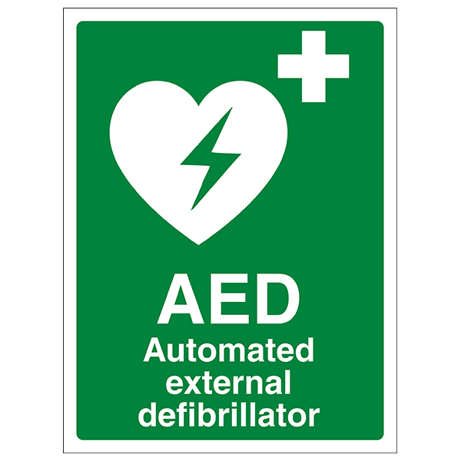
Royal Stoke University Hospital,

Newcastle Rd, Stoke-on-Trent
ST4 6QG
Tel 01782 715444

Appendix 3 – Course Map

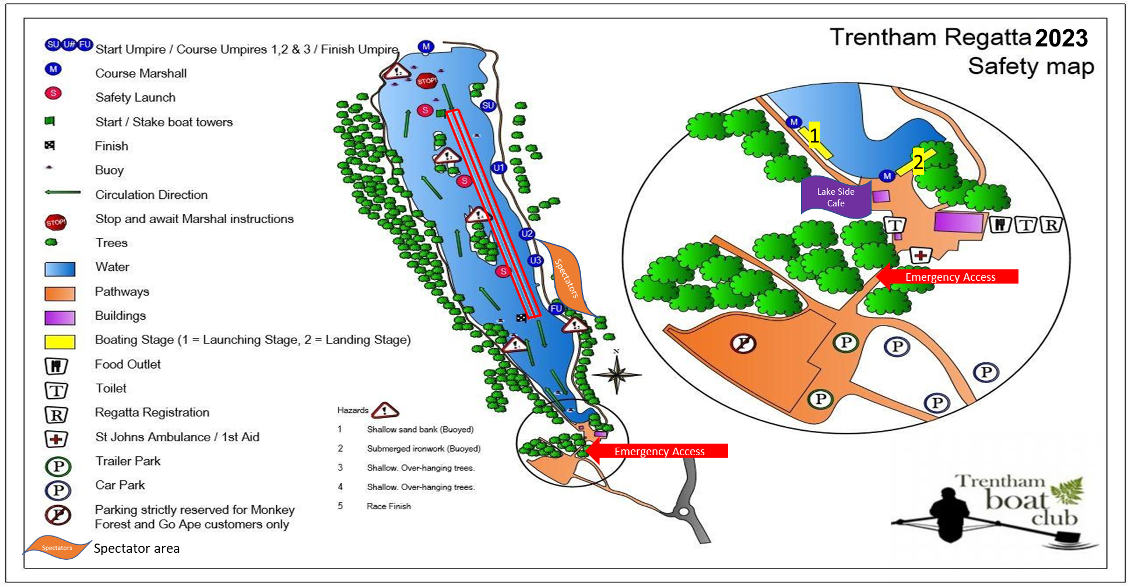

British Rules of Racing - https://www.britishrowing.org/wp-content/uploads/2024/03/2024-British-Rowing-Rules-of-Racing-V1.pdf
RowSafe - https://www.britishrowing.org/wp-content/uploads/2024/04/2024-RowSafe-British-Rowing.pdf

